**Project Report Template**

**Title of Project:** Smart Seasons , Smarter Crops  
**Name of the Innovator:** Pramodh H S  
**Start Date:** 27-10-2025

**End Date: 31-10-2025**

***Day 1: Empathise & Define***

*Step 1: Understanding the Need*

* Which problem am I trying to solve?

I’m solving the problem of low agricultural productivity due to poor seasonal planning. This web application educates farmers about India's crop seasons—Kharif, Rabi, and Zaid—helping them make smarter, season-aligned decisions to boost yields and sustainability.

* Who is affected by this problem?
* How did I find out about this? [Select whichever is applicable]
* Interviews
* Observation
* Online Research
* AI Tools

*Step 2: What is the problem?*

The problem is that **lack of awareness and planning around India's agricultural seasons**, which leads to poor crop selection, mistimed sowing, and reduced yields. Many farmers struggle to align their farming practices with the seasonal calendar—Kharif, Rabi, and Zaid—resulting in inefficiencies and missed opportunities for sustainable growth.

Why is this problem important to solve?

This problem is crucial because seasonal misalignment in farming leads to wasted resources, lower yields, and financial instability for farmers. By empowering them with seasonal knowledge, we promote food security, sustainable agriculture, and improved livelihoods across rural communities.

**Take-home task**

Ask 2-3 people what they think about the project:

* “It’s a great idea—many farmers don’t have access to structured seasonal guidance. A simple calendar and crop suggestions could really help.”
* “It’s a smart idea—many farmers don’t know the best time to plant certain crops, so this could really help improve their harvests.”
* “If it’s available in local languages and works offline, it could be a game-changer for rural communities.”
* I like how it simplifies complex information. The seasonal breakdown makes it easy to understand for people without a technical background.”

*AI Tools you can use for Step 1 and 2:*

**AI Tools Used:**

**1. Meta MGX**

* **Used as a no-code development tool to design and deploy the Smart Seasons , Smarter Crops app.**
* **It helps create immersive, educational web apps like this one for seasonal crop planning and farmer empowerment.**
* **ideal for building features combine interactive storytelling, data visualization, and educational content into immersive web experiences.**

**2. Copilot**

* **Used for idea generation, content planning, and structuring the seasonal farming education flow.**
* **Helped design interactive quiz questions, crop calendar logic, and user-friendly explanations for Kharif, Rabi, and Zaid seasons.**
* **Also useful for refining user interaction flow, crafting clear guidance for farmers, and enhancing the educational impact of the platform.**

**3. Web Application References (Structure Design):  
To design this seasonal crop planning platform, you can take reference from:**

* **Crop Calendar Models** – for structuring sowing and harvesting timelines across Kharif, Rabi, and Zaid seasons.
* **Interactive Quiz Interfaces** – for engaging users in learning through seasonal farming questions.
* **Educational Web Modules** – for delivering climate and crop insights in a simple, visual format.

***Day 2: Ideate***

*Step 3: Brainstorming solutions*

* List **at least 5 different solutions** (wild or realistic):
* **Seasonal Crop Planning Web App** – Helps farmers understand and align with Kharif, Rabi, and Zaid cycles for better yield.
* **Interactive Crop Calendar** – Visually guides sowing and harvesting periods based on seasonal conditions.
* **Farming Knowledge Quizzes** – Engages users with questions to reinforce seasonal crop awareness.
* **Climate & Crop Education Modules** – Provides simple explanations of weather patterns and suitable crops per season.
* **Farmer-Centric Design** – Built for accessibility with intuitive navigation and clear visuals.
* **AgriSeason Platform** – A complete digital experience built using Meta MGX, designed to empower farmers with seasonal insights and planning tools.

*Step 4: My favourite solution:*

*My favorite solution is AgriSeason, a complete digital platform designed to empower farmers with seasonal crop planning. It combines interactive crop calendars, climate-based crop recommendations, and engaging quizzes to build awareness of Kharif, Rabi, and Zaid cycles. Built using Meta MGX, the app is easy to access, update, and use anytime, making it a long-term, practical, and impactful solution for agricultural communities.*

*Step 5: Why am I choosing this solution?*

I am choosing AgriSeason because it combines seasonal crop planning, climate-based recommendations, and interactive learning in one platform. It is easy to use, accessible anytime, and designed to empower farmers with the knowledge to make informed agricultural decisions.

*AI Tools you can use for Step 3-5:*

**AI Tools for Step 3–5**

**1. Meta MGX**

* Used to **design and build the Smart Seasons,Smarter crops app** without coding.
* Helps create the **AI assistant, skill modules, and location-based features**.

**2. ChatGPT**

* Helps **brainstorm solutions** and generate ideas for career guidance features.
* Can **structure conversations** for the AI virtual assistant.
* Assists in writing content for skill modules, FAQs, and recommendations.

**3. AI Chatbot References (for design and flow)**

* **Dialogflow** – Understands user intent and conversation flow.
* **IBM Watson Assistant** – Helps design structured Q&A for personalized guidance.
* **Microsoft Bot Framework** – Shows how to connect user inputs with recommendations and actions.

**4. AI Research Tools**

* **Google Scholar / Research AI** – For exploring existing solutions and innovative ideas for Steps 3–5.
* **AI Text & Summarization Tools** – Helps summarize solutions, select the best approach, and present them clearly.

*AI Tools you can use for the take-home task:*

**Canva AI/CoPilot AI/Meta AI:** Use these mobile-based tools to generate images for the solution they want to design

***Day 3: Prototype & Test***

*Step 6: Prototype – Building my first version*

What will my solution look like?

* **Home Screen:** Welcomes the user and introduces the concept of seasonal crop planning with simple navigation.
* **Season Selection Interface:** Allows users to explore Kharif, Rabi, and Zaid seasons with visual cues and crop timelines.
* **Crop Calendar Module:** Displays sowing and harvesting periods for key crops in each season using intuitive visuals.
* **Quiz Interaction:** Engages users with seasonal farming quizzes to reinforce knowledge and track understanding.
* **Farmer Dashboard:** Summarizes completed modules, quiz scores, and provides personalized seasonal insights.
* **Learning Section:** Offers easy-to-understand content on climate conditions, crop suitability, and farming practices.

**Design Style:**

* Simple, intuitive, and easy to navigate for farmers with varying digital literacy.
* Bright and engaging visuals to make seasonal crop learning clear and enjoyable.
* Mobile-friendly layout for smooth access on smartphones in rural areas.

**Prototype Tools:**

* Built using **Meta MGX**, no coding required, with all features **interactive and testable**.

What AI tools will I need to build this?

**AI Tools Needed to Build :** Smart Seasons , Smarter Crops

1. **Meta MGX**

* No-code platform to design and deploy the seasonal crop planning app.
* Allows building interactive crop calendars, educational modules, and quiz-based learning without coding.

1. **ChatGPT (or similar LLMs)**

* To generate content, quiz questions, and seasonal crop explanations.
* Can help personalize farming recommendations based on seasonal context and user interaction.

1. **Web Application Design References**

* Crop calendar interfaces, educational modules, and quiz-based learning flows.
* To structure seasonal content, guide user navigation, and deliver farming insights effectively.

1. **AI Recommendation Tools** *(Optional but useful)*

* For suggesting suitable crops based on seasonal conditions and user-selected preferences.
* Could use ML-based models or existing AI APIs to personalize crop planning and optimize yield recommendations.

What AI tools I finally selected to build this solution?

1. **Coplit**
2. **Metamgx**

**< Build The Innovation>**

**<DASHBOAD OF THE TOOL>**

**Tool Link:**  **https://mgx-41w9yyp6odr.mgx.world**

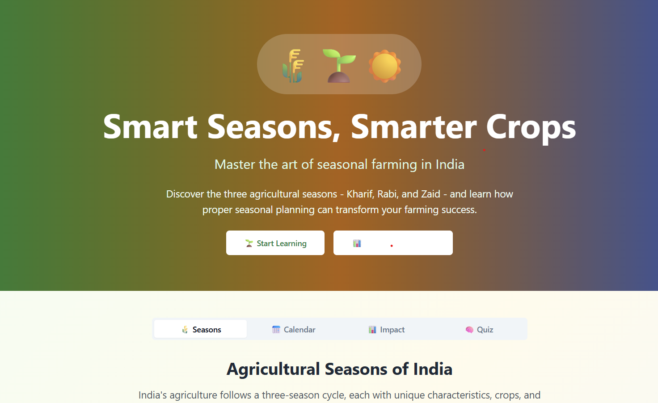

Internal Working of tool:

Seasons :

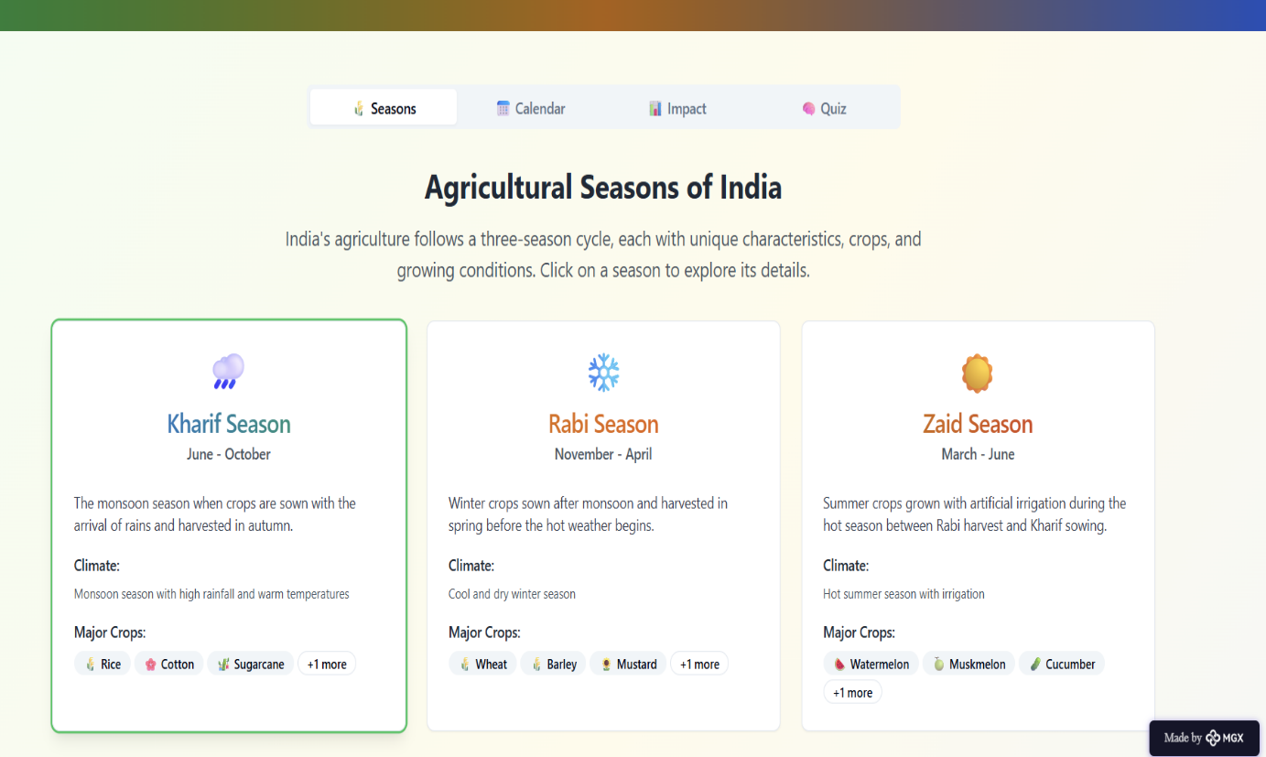

Calendar according to the different states and Crops

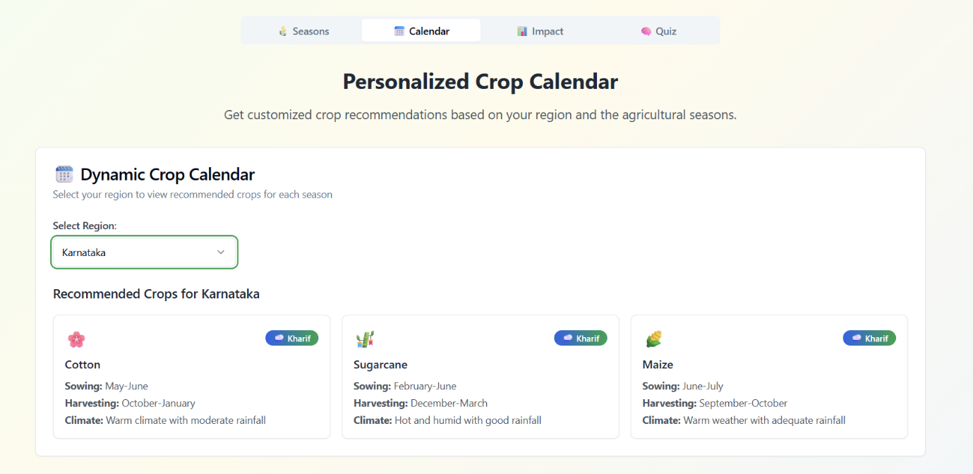

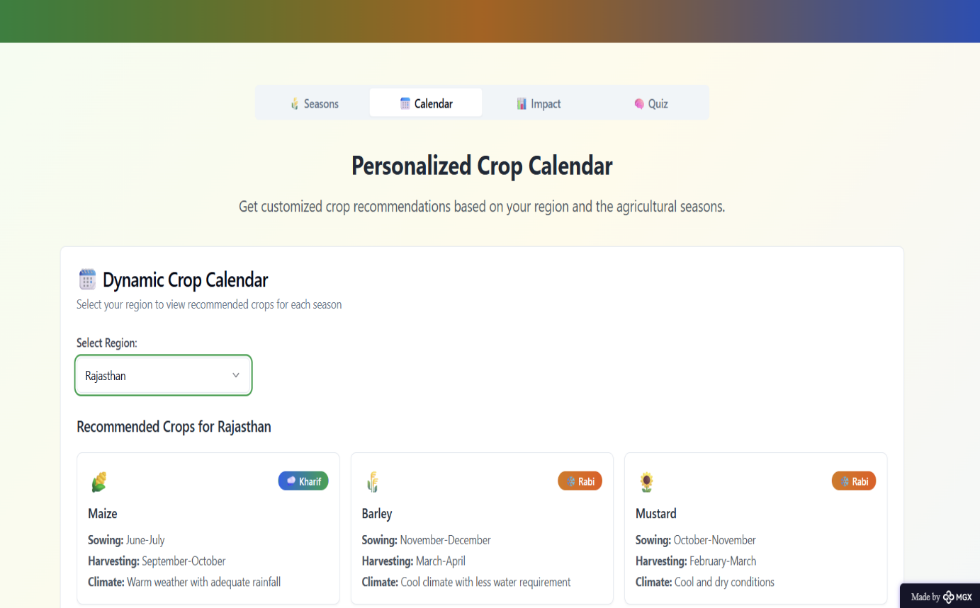

**Impact & Sustainability:**

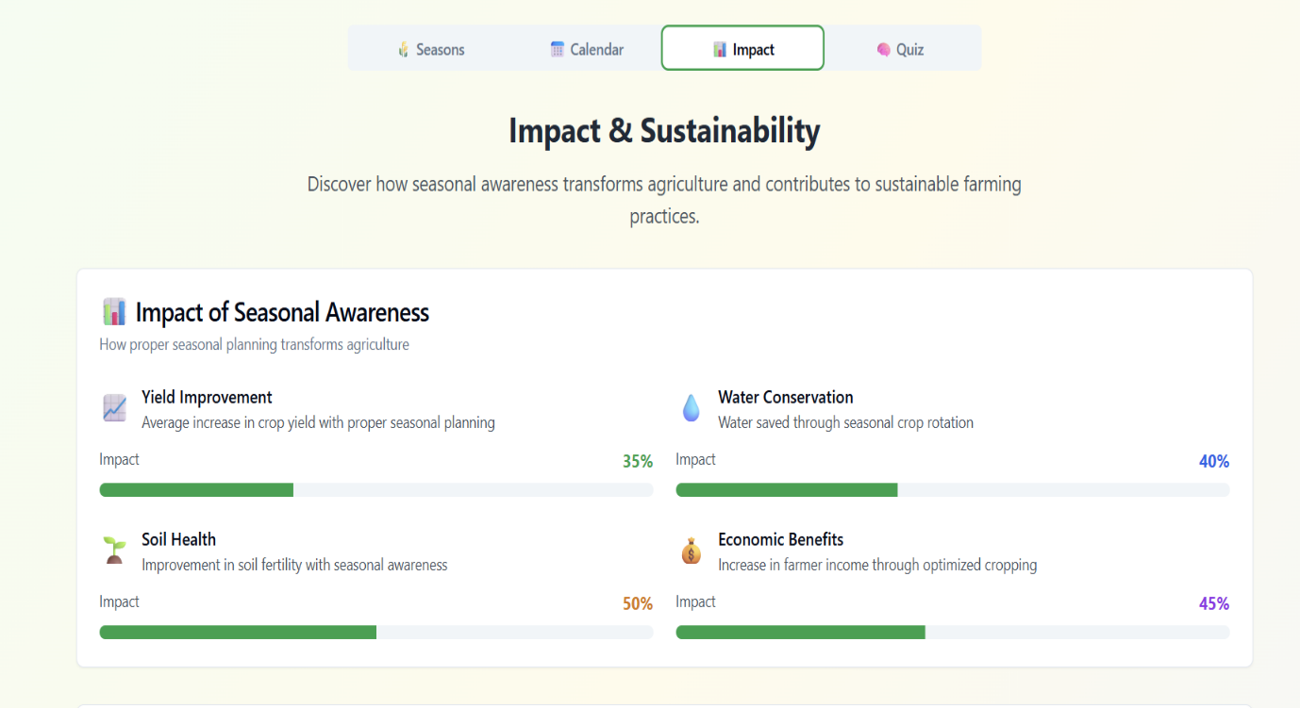

*Step 7: Test – Getting Feedback*

* Who did I share my solution with?

I shared my **Smart Seasons, Smart Crops** solution with:

* **Farmers from rural areas** – to get feedback on seasonal crop planning usefulness and clarity.
* **Agricultural educators and extension workers** – to understand how well it supports farming awareness and decision-making.
* **Family members of farmers** – to see if it helps households plan better and access seasonal crop information.
* **Peers and mentors** – for suggestions on improving features, design, and accessibility.

What feedback did I receive?

**Feedback: Pros and Cons**

**Pros (Positive Insights from Feedback):**

1. Users found the crop calendar and seasonal guidance helpful for planning agricultural activities.
2. The concept of combining education, quizzes, and seasonal awareness was appreciated for its practicality.
3. The platform’s simple design and mobile accessibility were praised as farmer-friendly features.

**Cons (Areas to Improve Noted in Feedback):**

1. Some users felt the seasonal content could be expanded with more crop-specific details
2. Certain interactive modules were not fully functional or accessible in the prototype version.
3. Limited integration with real-time weather or local farming data reduced the depth of recommendations.

**My Response for The Feedback:**  
Smart Seasons, Smart Crops is an idea created using a no-code tool (Meta MGX). As it’s an initial prototype, the resources and integrations are limited. To fully integrate all features and provide real-time crop recommendations, weather data, and localized farming support, we would need collaborations with agricultural platforms and organizations. The current limitations are due to the constraints of the prototype environment, but the concept demonstrates the potential, usability, and impact of the platform for rural farming communities.

**👍 What works well:**

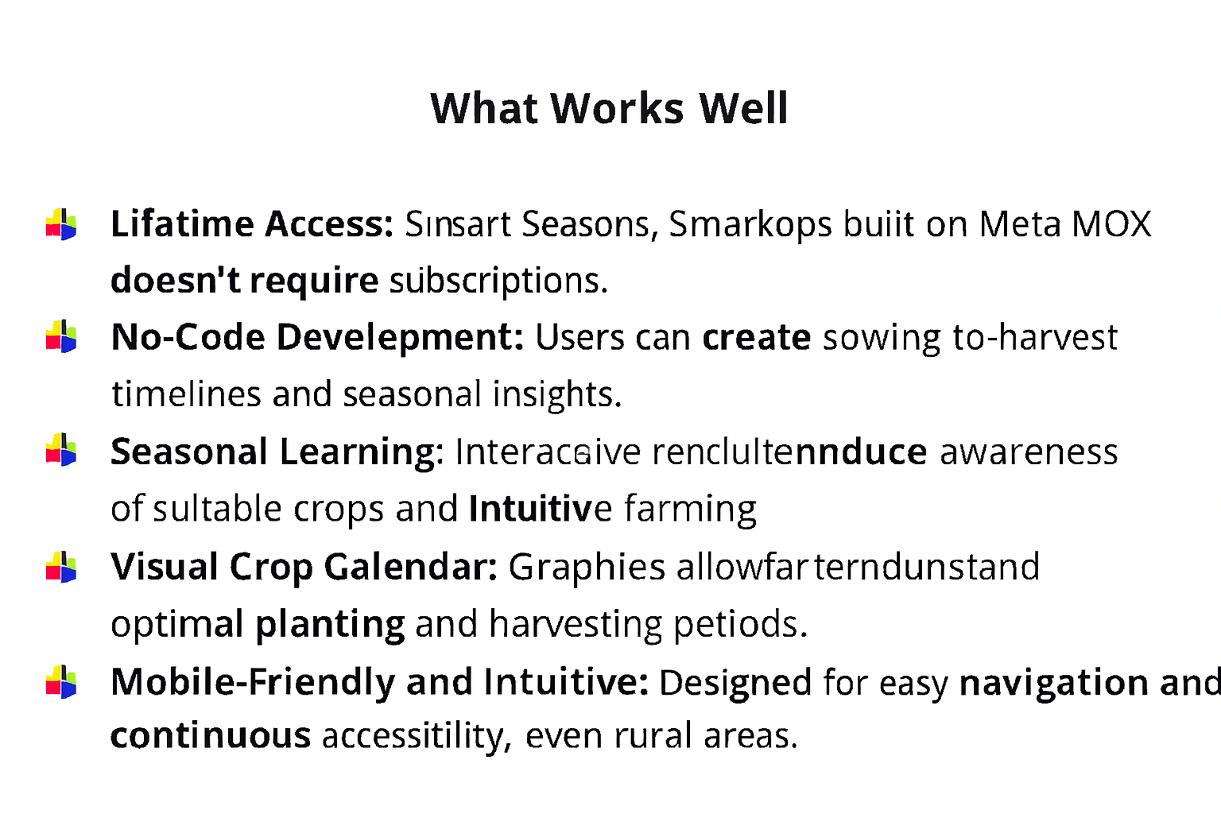

**🔧 What needs improvement:**

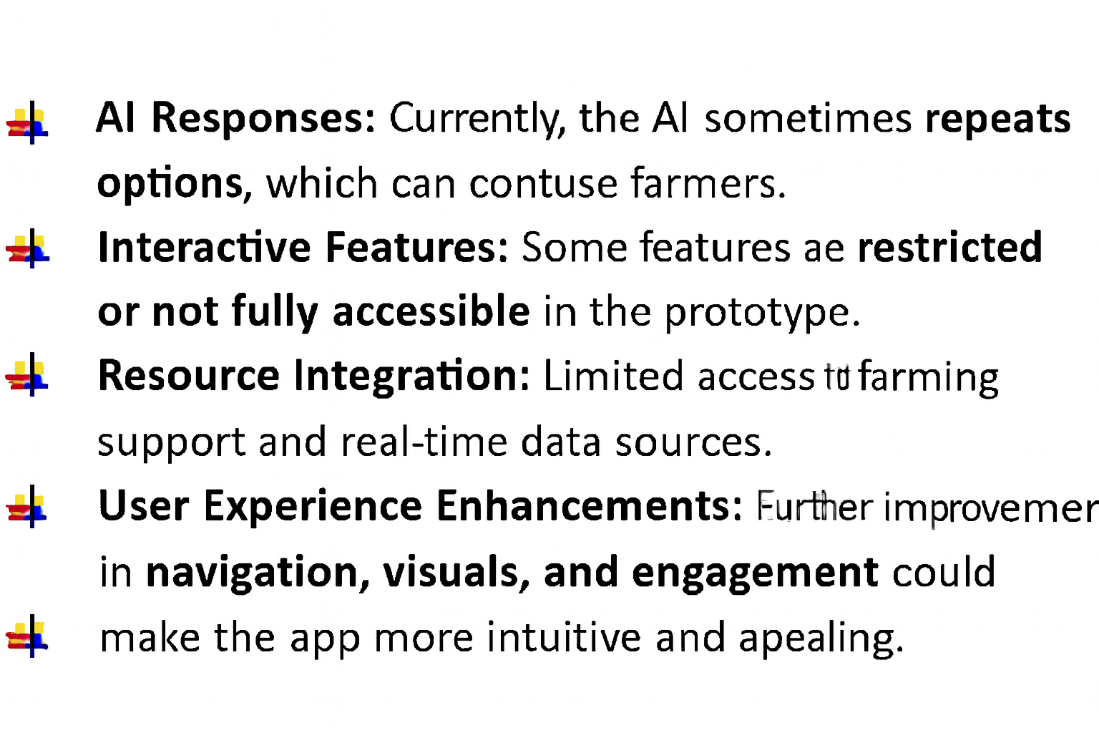*AI Tools you can use for Step 6-7:*

**ChatGPT/Perplexity AI/Claude AI/Canva AI/Chatling AI/Figma AI/Metamgx/Gamma AI**: You can use these tools to build solutions/models or mock-up dummy prototypes

***Day 4: Showcase***

*Step 8: Presenting my Innovation:*I am presenting **Smart Seasons, Smart Crops**, a digital crop planning and learning platform designed for farmers in rural communities. It features:

* **Seasonal crop calendars** that guide farmers through Kharif, Rabi, and Zaid cycles with intuitive visuals.
* **Interactive learning modules** that explain climate conditions, crop suitability, and best farming practices.
* **Engaging quizzes** to reinforce seasonal knowledge and improve decision-making.
* **A user-friendly, mobile-friendly interface** built on Meta MGX with lifetime access and easy updates.

**Impact:** Smart Seasons, Smart Crops helps farmers make informed agricultural decisions, improves seasonal awareness, and bridges the knowledge gap in rural farming communities.

**<SHOWCASE YOUR INNOVATION TO YOUR PEERS>**

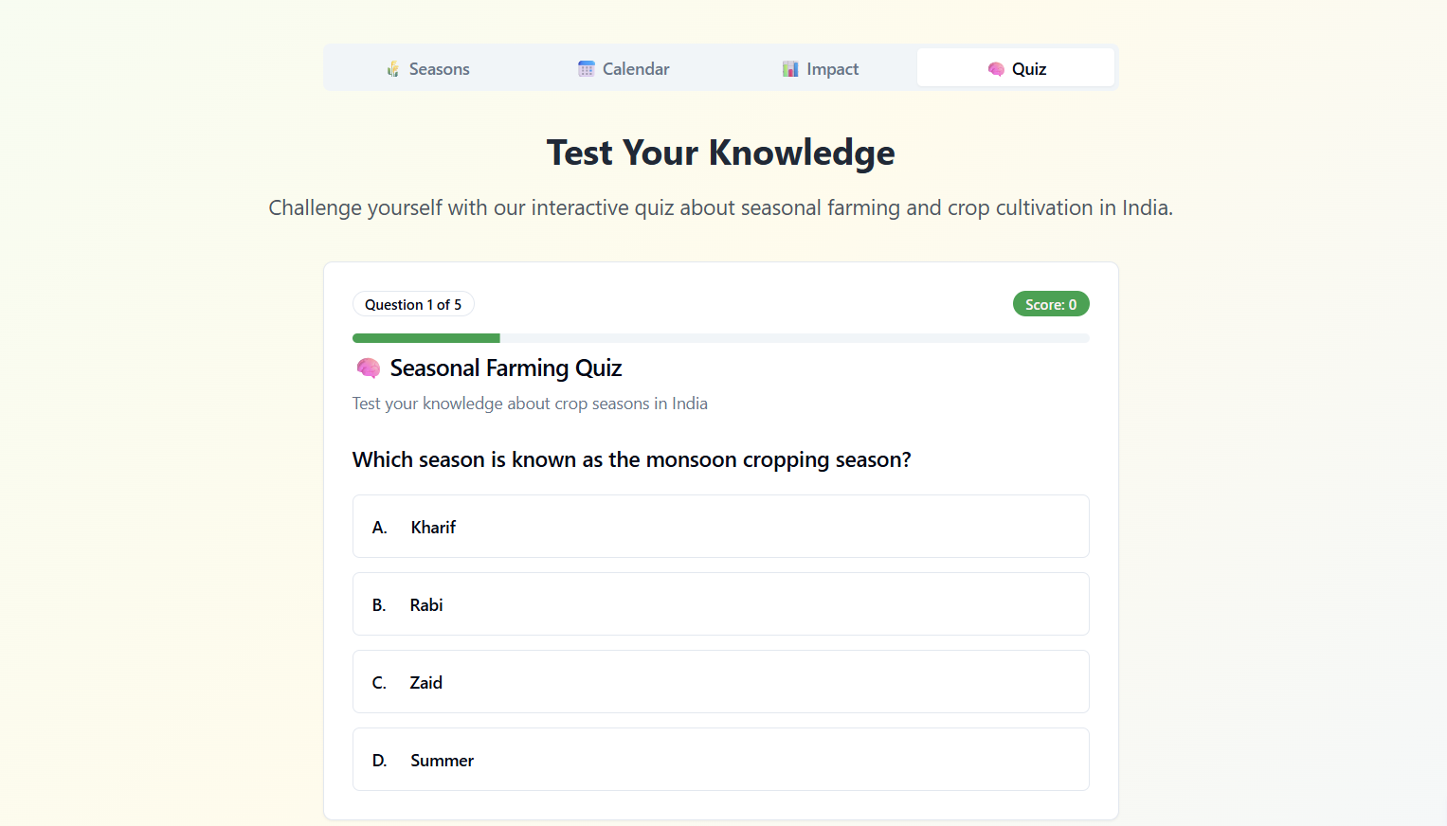

*Step 9: Reflections*

* What did I enjoy the most during this project-based learning activity?

I enjoyed building Smart Seasons, Smart Crops using a no-code tool and watching my idea take shape as a real, interactive platform. It was exciting to design the crop calendar, learning modules, and quizzes, and imagine how it could empower farmers to make informed seasonal decisions

* What was my biggest challenge during this project-based learning activity?

My biggest challenge was integrating all features smoothly in the prototype using a no-code tool—especially ensuring the crop calendars, educational content, and quiz interactions worked together effectively within the limitations of the platform.

**Take-home task**

<https://github.com/Pramodh8088/Smart-Seasons-Smarter-Crop>

*AI Tools you can use for Step 8:*

**Canva AI:** You can use this to design your pitch document. Download your pitch document as a PDF file and upload on GitHub